Driver Drowsiness Detection

**Vasundhara Saxena(12013828)**

**Computer Science and Engineering Dept, Lovely Professional University, Phagwara, Punjab, India**

*Abstract*—Worldwide, drowsiness has been a major factor in terrible incidents that have resulted in fatalities and serious injuries. Globally, the number of deadly injuries is rising every day. In recent years, studies have concluded that drivers who are sleep deprived and more exhausted are more likely to become drowsy. To decrease accidents brought on by this issue and promote transportation safety, this research presents a new experimental model for spotting driver drowsiness. The main objective of these devices is to increase their capacity for real-time sleepiness detection. To detect sleepiness, numerous gadgets that use various artificial intelligence algorithms have been developed. Therefore, our research also relates to driver sleepiness detection, which can determine a driver's tiredness by recognizing the face, then using eye tracking. The system compares the extracted eye image to the dataset. With the aid of the dataset, the system discovered that if the driver's eyes were closed for a specific distance, it might sound a warning. This paper focuses to resolve the problem of drowsiness detection with an accuracy of 97% and helps to reduce road accidents.

Keywords – Drowsiness, Deep Learning, Convolutional Neural Networks, Face Detection, Python, Keras, Drowsiness Detection

# **INTRODUCTION**

Drowsiness, which is defined as the need to rest-induced condition of sleepiness, can result in symptoms that significantly affect how well tasks are performed, such as decreased response time, brief loss of awareness, or microsleeps (blinks lasting more than 500 ms), to name a few [1]. Degrees of performance impairment brought on by ongoing weariness can be comparable to those brought on by alcohol [2,3]. These symptoms are highly dangerous when driving because they greatly increase the likelihood that drivers will miss exits or road signs, drift into other lanes, or even crash their car and cause an accident [4]. Our foundation for this work is the following: frontal photos of the driver will be captured by a camera mounted on a car, and these images will be analyzed using artificial intelligence (AI) methods like deep learning to determine whether or not the driver is sleepy. The technology will be able to warn the driver and avoid accidents by using that information. Given that the ADAS will have multiple integrated features, one of the limitations placed on the module discussed in this work is to prevent false alarms from activating, which could distract the driver and force him or her to deactivate the ADAS.

The use of a non-intrusive approach to detect fatigue from sequences of photographs, which is currently an open challenge, is the main originality of this work. The experimental methodology used in most of the works that are currently available involves removing and classifying individual frames from each video and then determining whether the classification is accurate or not. However, this methodology ignores the inherent relationship between successive images, making false positive measurements less reliable. There are currently few studies that evaluate the systems on whole movies and count the alerts raised during each video (which is required when determining how many false alarms were raised over time).

As a result, the ideas in this paper can serve as a beginning point for the creation of such systems.

Utilizing neural networks with many layers in their models, deep learning algorithms have the capacity to automate the feature extraction process [5, 6]. Convolutional neural networks (CNNs), a particular subset of deep learning algorithms, are particularly effective at computer vision because they can identify patterns and distinguish properties in images [7]. Transfer learning is a crucial CNN-related idea [8]. This method entails taking a model that has already been trained to handle one problem in a related domain, such as detecting dogs in photos, and applying it to another, such as detecting cats. The plan is to build a new CNN with new layers that have been trained and adjusted to address the newly given problem as the top layers, while the first layers correspond to the lower layers of the pre-trained model. In this manner, the pre-trained model's knowledge serves as the foundation for the new model.

* 1. **General Architecture**

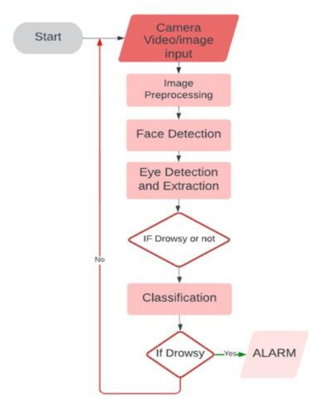

Fig.1. General Architecture

# **LITERATURE REVIEW**

To increase the effectiveness and speed of the sleepiness detection process, a number of techniques were employed in a tender. This section's main focus is on the techniques and tactics previously employed to detect sleepiness. The first approach is based on driving patterns, which additionally consider vehicle characteristics, traffic conditions, and driving styles. You can establish your driving style by calculating steering wheel movement or deviation from lane position [9][10]. To keep an automobile in its lane while driving, the steering wheel must be constantly under control. Krajewski et al.'s [11] method of detecting driver drowsiness has a 97% accuracy rate based on the relationship between fatigue and micro-adjustments. A lane deviation strategy can also be used to assess the driver's level of fatigue. In this case, the position of the car in respect to a lane is monitored and inspected to search for symptoms of indolence [12]. The approaches based on driving habits, on the other hand, rely on the type of vehicle, the driver, and the traffic conditions.



Fig. 2. Video Preprocessing outline

Data from physiological detectors, such as electrocardiogram (ECG), electroencephalogram (EEG), and electrooculography (EOG) data, are used in the alternative category of approaches. EEG signals convey data on the activity of the brain. Three primary signals—delta, theta, and nascence—are utilized to assess driver fatigue. Theta and delta signals increase while nascence signals scarcely alter when a driver is fatigued.

## **Early Approaches**

Early attempts to identify driver intoxication used conventional computer vision methods. These methods frequently analyzed facial features, such as eye closure and head attitude, but they had trouble adapting to changes in lighting and head motions (Huang et al., 2015).

## **The Rise of Deep Learning**

Driver drowsiness detection has been transformed by the development of deep learning, particularly Convolutional Neural Networks (CNNs) and Recurrent Neural Networks (RNNs). While RNNs have been used for time-series data processing, such as steering wheel dynamics and vehicle speed, CNNs have proved crucial in image-based drowsiness detection (Singh et al., 2018).

## **Image-Based Drowsiness Detection**

The use of CNNs to examine pictures, including driver facial expressions, eye movements, and head movements, is the subject of a sizable body of study. By studying extensive datasets, these models can successfully distinguish between alert and drowsy states (Zhang et al., 2020).

## **Multimodal Approaches**

Data from numerous sensors, including cameras, accelerometers, and steering angle sensors, are being combined, according to some recent studies. These multimodal systems seek to increase sleepiness detection's robustness and accuracy in a variety of environments (Xu et al., 2021).

## **Real Time Applications**

Systems for real-time detection are essential for avoiding accidents. To keep drivers, awake and safe, many researchers have created systems that provide timely warnings to the driver, such as auditory alerts or haptic feedback (Wang et al., 2019).

## **Future Directions**

Deep learning applications for driver sleepiness detection are constantly changing. Future studies should concentrate on enhancing model robustness to lighting situations, creating fresh multimodal strategies, and investigating real-world deployment in automobiles, which may require addressing issues with power efficiency and hardware limitations.

# **BACKGROUND AND RELATED WORKS**

According to the source of the data used for this measuring, there are two distinct techniques to determine a driver's level of sleepiness. There are systems that employ parameters gathered from the driver themselves, while other systems monitor the state of the vehicle to gauge the driver's level of weariness.

#### **Systems focused on the vehicle**

The most frequently investigated metrics in studies on the examination of the vehicle state and its relationship to fatigue are steering wheel behaviors or lane departures [13,14,15]. To reach their goals, [16] performs data fusion on various metrics using other car-related factors, such as the vehicle's position or the steering wheel's tilt. Even while the driver's performance on skill-based tasks may be suffering because of drowsiness, this effect does not appear until much later, making it impossible to identify the early signs of exhaustion [17].

#### **Systems focused on the driver**

Electroencephalograms (EEG) and electrooculograms (EOG) are two of the most accurate methods of assessing fatigue [18], but in actual driving situations, drivers frequently reject these kinds of devices. Their primary flaw is that they demand that the driver wear electrodes over their heads and around their eyes, making them obtrusive systems that drivers dislike and refuse.

Due to this restriction, the most widely used systems for detecting driver weariness are those that use a camera mounted on the car to take pictures of the driver. In this study, we'll concentrate on using the driver's condition to identify the early signs of drowsiness.

This method is used in several works, which employ a wide range of characteristics and approaches to detect them. For instance, in [19], the landmarks of the driver's face—a collection of points that identify the eyes, brows, nose, mouth, and facial shape—are obtained and then used to calculate parameters like the percentage of eye closure (PERCLOS). These features are then added to a support vector machine (SVM) that determines whether the driver is fatigued.

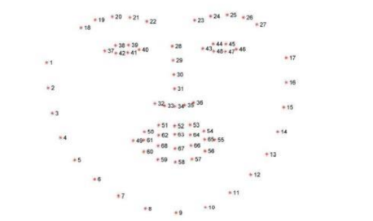

Fig. 3. Facial landmarks obtained.

* 1. **Tayab Khan et al. [20]**

A picture-based framework for the detection and assessment of tiredness based mostly on someone's eyes is suggested by Tayab Khan et al. [20]. A framework like this has the potential to save lives because it may be useful in a variety of situations, such as detecting driver drowsiness.

This system uses a video camera situated in front of the driver to continuously video record and display the driver's status in real time.

* 1. **Wanghua Deng's [21]**

Support a device called DriCare that uses video snapshots to detect signs of driver fatigue such as yawning, blinking, and length of eye closure without fitting our bodies with gadgets. They developed a novel face-tracking algorithm to increase monitoring accuracy due to the inadequacies of earlier techniques.

Additionally, based on 68 critical parameters, we developed a brand-new detection approach for face regions.

Then they evaluate the kingdom of the drivers using those face regions. DriCare can notify the driver when to use tiredness caution by combining the eyes and mouth functions. The experimental results demonstrated that DriCare completed rounds with an accuracy of 92%.

* 1. **Shakeel et al. [22]**

Created a 350-photo custom dataset using Mobile Net-SSD architecture. The model was modified to be suitable for a mean normal accuracy of 0.84. The system was efficient and cost-effective since the calculation could be sent to an Android device and the digital camera circulation could be managed continuously.

In order to predict the degree of sluggishness, Celona et al. [22] presented a dream based Perform a Few Obligations Driver Observing Structure that separates the position of the eyes, lips, and head into separate components. This analysis was successful using the NTHU [dataset].

The System here that Pavan Vittal, Nikhil C. Bhat2, and Parikshith suggest uses a deep learning methodology.

1. **METHODOLY**

The proposed system employs a convolution neural network application. A special sort of deep neural network called a convolutional neural network is extremely important for the functions of image classification.

The purpose of this effort is to create a system that can gauge a driver's level of weariness using a series of photographs that are captured in a way that makes the subject's face visible.

The driver based ADAS system that the sleepiness detection system created in this work is a part of has two major restrictions: early detection and minimizing the number of false positives. To prevent false positives that would make the driver bored and turn off the ADAS without using the other features, the system is designed to alert the driver only in genuine circumstances of drowsiness.

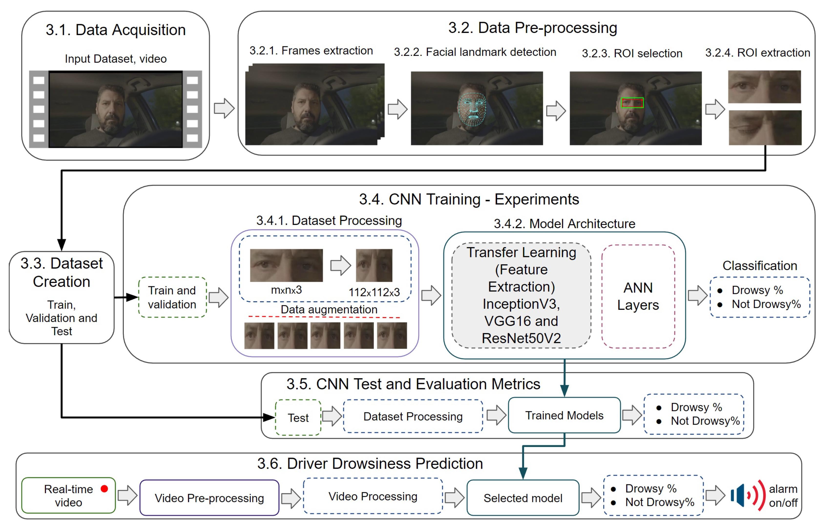

Fig. 4. Methodology for the detection of driver drowsiness

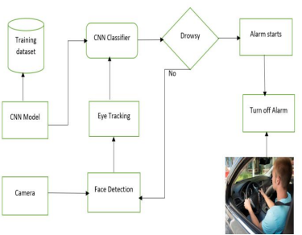

Fig. 4.1 Proposed System

1. **Data Acquisition**

The database used is from Kaggle. This dataset contains 4 directories:

1. Closed_eyes – 726 pictures
2. Open_eyes – 726 pictures
3. Yawn – 725 pictures
4. no_yawn – 723 pictures

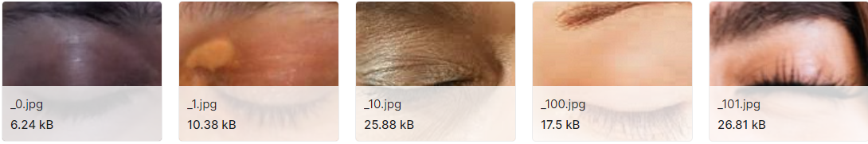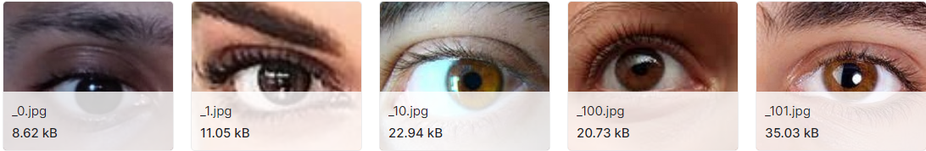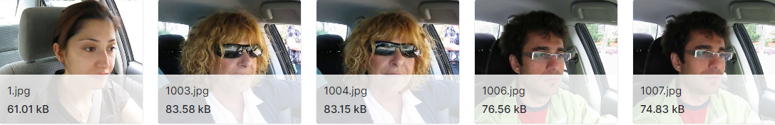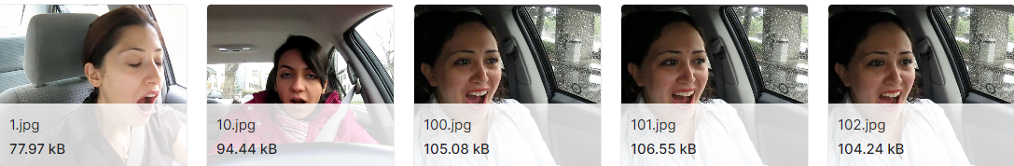

Fig. 4.2 Dataset images

in the above described proposed system we are taking some 2,900 images that will be trained and then extracted by using CNN model

1. **Data Preprocessing**

There are two defined parameters `direc` ans `face_cas_path`, which are set to default values pointing to specific directory paths. `yawn_no` is initialized as an empty list. It is used to store data of the image and the labels (0 for yawn and 1 for no_yawn). The size of the image is set to 145 which indicates the desired image for preprocessing.

We have two labels (“yawn” and “no_yawn”) present that represents the two classes for classification.

There is a loop present over these two categories that takes the value for yawn and no_yawn. It iterates over all the images in every specified category’s directory. After it applies the face detection using the ‘detectMultiScale’ method. For each detected face, it draws a green rectangle around the face on the image.Furthermore, there are another two defined parameters for the detection of drowsiness and that is for the position of eyes whether it is ‘closed’ or ‘open’. This is used as a input for training a deep learning model for eye state classification.

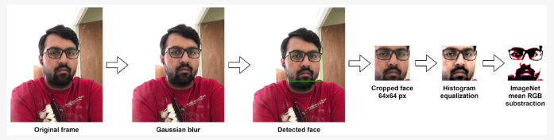

Fig. 4.3 Preprocessing of the driver’s face

1. **Model Architecture**

**1. Convolutional Layers:**

Convolutional layers (Conv2D) are the fundamental building blocks of CNNs. They consist of filters (kernels) that scan the input image to detect features. In your code, you have four convolutional layers with decreasing filter sizes (from 256 to 32).

(ReLU - Rectified Linear Unit) are applied after each convolution that introduces non-linearity.

**2. Max-Pooling Layers:**

Max-pooling layers (MaxPooling2D) down sample the spatial dimensions of the feature maps obtained from the convolutional layers. They retain the most salient features by selecting the maximum value in a local region. In the code, max-pooling layers follow each convolutional layer, reducing the spatial dimensions and emphasizing the most significant features.

**3. Flatten Layer:**

The Flatten layer is used to convert the 2D feature maps obtained from the previous layers into a 1D vector. This prepares the data for fully connected layers.

**4.Dropout Layer:**

Dropout is a regularization technique that randomly sets a fraction of the input units to zero during each update, helping prevent overfitting.

**5. Fully Connected Layers:**

After the Flatten layer, you have two fully connected (Dense) layers. These layers perform the final classification based on the extracted features.

The first Dense layer has 64 neurons with ReLU activation. The output layer consists of 4 neurons with softmax activation, which is suitable for multi-class classification problems. In this case, it seems like you're classifying into four categories.

**6. Model Compilation:**

The model is compiled using the compile method. In our model we have:

Loss function: "categorical_crossentropy," which is commonly used for multi-class classification problems.

Metrics: "accuracy" to monitor the accuracy of the model during training.

Optimizer: "adam," which is a popular choice for stochastic gradient descent.

In summary, this CNN architecture is designed for a multi-class image classification task, taking input images of size (145, 145, 3) and classifying them into one of four categories. It includes convolutional layers for feature extraction, max-pooling for down sampling, and fully connected layers for classification.

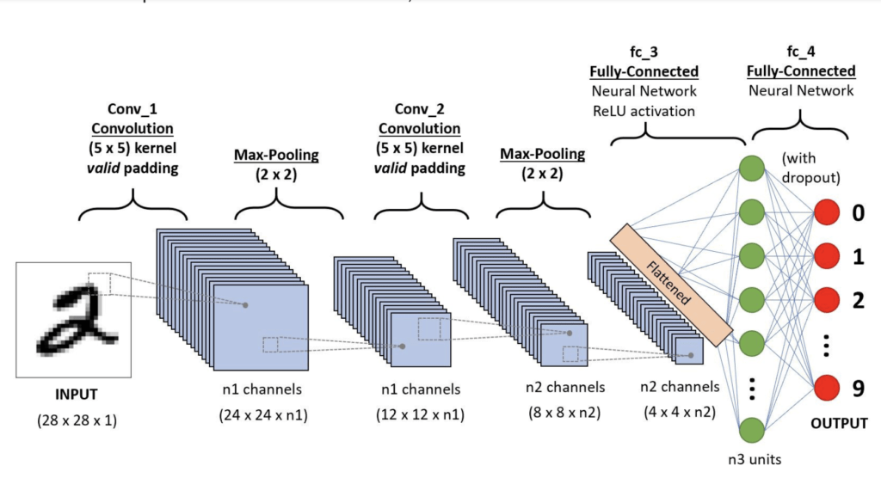

Fig. 4.3. CNN Architecture

1. **EXPERIMENTAL RESULTS**

The dataset contains approximate 2900 images of closed and open eyes and yawn and no yawn in which is divided into training and testing features and validation. We extract the dataset and select the features required for classifying the model. The result will be obtained gives following accuracy:

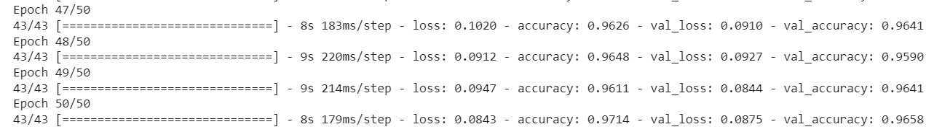

After running for 50 epochs, the accuracy is 97%.

We save the model and apply that in live detection for detecting drowsiness of driver by capturing images of drivers. In the process of applying model, we use haar cascade model also which is used to detect objects that are eyes on face when trained with lot of negative and positive images. Then we detect for both left and right eye part using prediction model and check for drowsiness. In the final result we open webcam using Open CV library and predict for drowsiness in the condition that if person closes eyes for more than 10seconds then alarm starts and alert the driver and prevent accidents.

1. **CONCLUSION AND FUTURE SCOPE**

The research described an enhanced CNN-based machine learning-based drowsiness detection system. The major goal is to create a system with great performance that is lightweight enough to be implemented in embedded systems. In order to identify drowsy driving behavior, the system was able to recognize face landmarks from photographs taken on a mobile device and feed them to a CNN-based trained Deep Learning model. The accomplishment in this case was the creation of a deep learning model that is compact but has a high level of accuracy. For all categories where the model's maximum size did not exceed 75KB, the model reported here averaged an accuracy of 83.33%. To support cutting-edge driving assistance programmes or even a mobile device to provide intervention when drivers are tired, this system can be readily implemented into dashboards in the upcoming generation of automobiles.

This technology has drawbacks, such as the inability to see face characteristics when wearing sunglasses and poor

lighting. Even in poor illumination, there is still space for performance improvement and better facial feature detection given the current state of the technology.

A promising field of system learning model for decreasing accidents caused by drowsiness is neural networks. The version that was created was accurate, and by optimizing the video input, it could be used to its full potential in real-world applications.

Even so, the current webcam utility may successfully inform the user within two milliseconds of meeting the closed eye time requirement. Up to a point, adding more convolutional layers can be effective, but dense layers can still stand out thanks to their expanding layers or diverse population of neurons. Instead of giving workers the required rest, Driver-Factories or commercial car companies should exploit it as a means of overworking the workforce.

Drivers may also rely on the alarm to wake them up and feel safer operating a vehicle while fatigued, but even an alert that comes on 1 second after you fall asleep may be too late to prevent an accident. Overall, this endeavor may be considered a success. Our goal was to develop a model that could accurately predict whether or not a stationary human would have their eyes closed.

1. **REFERENCES**
2. PAHO. Road Safety. 2022. Available online: https://www.paho.org/en/topics/road-safety (accessed on 9 February 2023).
3. N. C. for Statistics and Analysis, “Crash Stats: Drowsy Driving 2015,” October 2017. [Online]. Available:<https://crashstats.nhtsa.dot.gov/Api/>Public/ViewPublication/812446
4. M. Walker, Why We Sleep: Unlocking the Power of Sleep and Dreams. Scribner, 2017. [Online]. Available: https://books.google.com.qa/books?

id=8bSuDgAAQBAJ

1. W. H. Organization, “The top 10 causes of death.”

[Online].Available:https://www.who.int/newsroom/fact-sheets/detail/the-top-10-causes-of-deaTh

1. C. S. Wei, Y. T. Wang, C. T. Lin, and T. P. Jung, “Toward Drowsiness Detection Using Non-hair-Bearing EEG-Based Brain-Computer Interfaces,” IEEE Transactions on Neural Systems and Rehabilitation Engineering, 2018.
2. V. J. Kartsch, S. Benatti, P. D. Schiavone, D. Rossi, and L. Benini,“A sensor fusion approach for drowsiness detection in wearable ultra-low-power systems,” Information Fusion, vol. 43, pp. 66–76, Sep.2018. [Online]. Available: https://www.sciencedirect.com/science/article/pii/S1566253517306942
3. S. Tateno, X. Guan, R. Cao, and Z. Qu, “Development of Drowsiness Detection System Based on Respiration Changes Using Heart Rate Monitoring,” in 2018 57th Annual Conference of the Society of Instrument and Control Engineers of Japan, SICE 2018, 2018, pp. 1664–1669.
4. A. Kamilaris and F. X. Prenafeta-Bold, “Deep learning in agriculture:A survey,” Computers and Electronics in Agriculture, vol. 147, pp. 70– 90, 2018. [Online]. Available: http://www.sciencedirect.com/science/article/pii/S0168169917308803
5. M. Tayab Khan, H. Anwar, F. Ullah, A. Ur Rehman, R. Ullah, A. Iqbal,B.-H. Lee, and K. S. Kwak, “Smart Real-Time Video Surveillance Platform for Drowsiness Detection Based on Eyelid Closure,” Wireless Communications and Mobile Computing, vol. 2019, pp. 1–9, 2019.
6. M. F. Shakeel, N. A. Bajwa, A. M. Anwaar, A. Sohail, A. Khan, and H. ur Rashid, “Detecting Driver Drowsiness in Real Time Through Deep Learning Based Object Detection,” 2019, pp. 283–296. [Online]. Available: http://link.springer.com/10.1007/978-3-030-20521-8{ }24
7. L. Celona, L. Mammana, S. Bianco, and R. Schettini, “A multi-task CNNframework for driver face monitoring,” IEEE International Conference on Consumer Electronics - Berlin, ICCE-Berlin, vol. 2018-Septe, pp. 1–4,2018.

C.-H. Weng, Y.-H. Lai, and S.-H. Lai, “Driver drowsiness detection via a hierarchical temporal deep belief network,” in Asian Conference on Computer Vision. Springer, 2016, pp. 117–133

1. Torrey, L.; Shavlik, J. Transfer learning. In Handbook of Research on Machine Learning Applications and Trends: Algorithms, Methods, and Techniques; IGI Global: Hershey, PA, USA, 2010; pp. 242–264. [Google Scholar]
2. Lugaresi, C.; Tang, J.; Nash, H.; McClanahan, C.; Uboweja, E.; Hays, M.; Zhang, F.; Chang, C.L.; Yong, M.G.; Lee, J.; et al. Mediapipe: A framework for building perception pipelines. arXiv 2019, arXiv:1906.08172. [Google Scholar]
3. Kwon, K.A.; Shipley, R.J.; Edirisinghe, M.; Ezra, D.G.; Rose, G.; Best, S.M.; Cameron, R.E. High-speed camera characterization of voluntary eye blinking kinematics. J. R. Soc. Interface 2013, 10, 20130227. [Google Scholar] [CrossRef] [PubMed][Green Version]

Deep CNN: A Machine Learning Approach for Driver Drowsiness Detection Based on Eye State. Rev. d’Intell. Artif. 2019, 33, 461–466. [Google Scholar] [CrossRef][Green Version]

1. Dalal, N.; Triggs, B. Histograms of oriented gradients for human detection. In Proceedings of the 2005 IEEE Computer Society Conference on Computer Vision and Pattern Recognition (CVPR’05), San Diego, CA, USA, 20–26 June 2005; Volume 1, pp. 886–893. [Google Scholar] [CrossRef][Green Version]
2. Tan, M.; Le, Q.V. EfficientNet: Rethinking Model Scaling for Convolutional Neural Networks. arXiv 2019, arXiv:1905.11946. [Google Scholar]
3. Deng, J.; Dong, W.; Socher, R.; Li, L.J.; Li, K.; Fei-Fei, L. ImageNet: A large-scale hierarchical image database. In Proceedings of the 2009 IEEE Conference on Computer Vision and Pattern Recognition, Miami, FL, USA, 20–25 June 2009; pp. 248–255. [Google Scholar] [CrossRef][Green Version]
4. Kazemi, V.; Sullivan, J. One millisecond face alignment with an ensemble of regression trees. In Proceedings of the 2014 IEEE Conference on Computer Vision and Pattern Recognition, Columbus, OH, USA, 23–28 June 2014; pp. 1867–1874. [Google Scholar] [CrossRef][Green Version]
5. Soukupová, T.; Cech, J. Eye-Blink Detection Using Facial Landmarks. In Proceedings of the 21st Computer Vision Winter Workshop, Rimske Toplice, Slovenia, 3–5 February 2016; pp. 22–29. [Google Scholar]
6. Mamdani, E.; Assilian, S. An experiment in linguistic synthesis with a fuzzy logic controller. Int. J. Man-Mach. Stud. 1975, 7, 1–13. [Google Scholar] [CrossRef]

Leekwijck, W.V.; Kerre, E.E. Defuzzification: Criteria and classification. Fuzzy Sets Syst. 1999, 108, 159–178. [Google Scholar] [CrossRef]

1. Schroff, F.; Kalenichenko, D.; Philbin, J. FaceNet: A Unified Embedding for Face Recognition and Clustering. In Proceedings of the IEEE Computer Society Conference on Computer Vision and Pattern Recognition, Boston, MA, USA, 7–12 June 2015; pp. 815–823. [Google Scholar] [CrossRef][Green Version]
2. Parkhi, O.M.; Vedaldi, A.; Zisserman, A. Deep Face Recognition. In Proceedings of the British Machine Vision Conference, Swansea, UK, 7–10 September 2015. [Google Scholar]